React.createElement

**createElement**

createElement lets you create a React element. It serves as an alternative to writing JSX.

syntax

const element = createElement(type, props, ...children)

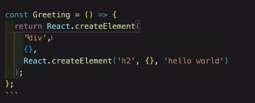

Example

createElement(type, props, ...children)

Call createElement to create a React element with the given type, props, and children.

import { createElement } from 'react';

function Greeting({ name }) {

return createElement(

'h1',

{ className: 'greeting' },

'Hello'

);

}